Customer Churn Prediction
Final Capstone Report
NexAfrica Machine Learning Internship - 5 Week Program
Prepared by: GLORIA BOATENG

Executive Summary
This project developed a binary classification model to predict customer churn for a telecommunications provider, using the Telco Customer Churn dataset (7,043 customers, 21 original features). Across five weeks, the project moved from raw data to a tuned, production-ready Random Forest model achieving 77.3% recall on the churn class, a substantial improvement over the 49-52% recall of initial baseline models. Six churn drivers were identified and validated both through exploratory analysis and independently confirmed by the final model's feature importance. Six actionable business recommendations are provided, each tied to a specific, quantified finding.

1. Business Understanding
Customer churn refers to a subscriber discontinuing their relationship with a service provider, cancelling a line, letting a subscription go inactive, or switching to a competing network. In a competitive telecom market, retaining existing customers is significantly cheaper than acquiring new ones, particularly since high-usage customers are often the first to leave for a better deal elsewhere. Beyond its direct revenue impact, churn also functions as a diagnostic signal for underlying issues such as poor network quality, weak customer service, or uncompetitive pricing.
This project builds a binary classification model that takes customer-level data (usage, tenure, billing, contract, and service details) as input and predicts whether a customer is likely to churn, with an associated probability score for risk-based prioritization. This allows a company to proactively target at-risk customers with retention offers rather than reacting only after a customer has already left.

2. Data Understanding and Preparation
The dataset contains 7,043 customer records and 21 columns, with Churn as the binary target variable (73.46% No, 26.54% Yes). Data cleaning addressed three issues: whitespace in column names, a text-formatted TotalCharges column requiring numeric conversion, and 11 missing TotalCharges values corresponding to new customers with zero tenure (filled with 0, since a customer with no tenure has logically accrued no charges). No duplicate rows or duplicate customer IDs were found, and all categorical values were confirmed clean and consistent.

3. Exploratory Data Analysis - Key Churn Drivers
Six insights were identified and validated through the data:
1. Contract type: Month-to-month customers churn at 42.7%, versus 11.3% (one-year) and 2.8% (two-year), a roughly 15x difference.
2. Tenure: Churned customers had an average tenure of 18.0 months, versus 37.6 months for retained customers.
3. Monthly charges: Churned customers paid an average of $74.44/month, versus $61.27/month for retained customers.
4. Internet service type: Fiber optic customers churn at 41.9%, versus 19.0% (DSL) and 7.4% (no internet).
5. Payment method: Electronic check customers churn at 45.3%, roughly 3x the rate of automatic payment methods (15-19%).
6. Senior citizen status: Senior citizens churn at 41.7%, nearly double the rate of non-seniors (23.6%). Gender showed no meaningful effect (26.9% vs 26.2%).

4. Feature Engineering
Three features were engineered based on the above findings:
- TenureGroup: bucketed tenure into 0-1, 1-2, 2-4, and 4+ year ranges. Churn dropped consistently across groups: 47.4% to 28.7% to 20.4% to 9.5%.
- NumServices: count of subscribed add-on services (0-8). Churn was highest at 0 services (43.8%) and lowest at 7-8 services (12.4%, 5.3%), reflecting the retentive effect of deep service adoption.
- SpendingTier: MonthlyCharges split into Low/Medium/High tiers. Churn increased monotonically: 15.9% to 29.7% to 34.1%.

5. Model Development and Optimization
Three classification models were trained and evaluated: Logistic Regression (baseline), Decision Tree, and Random Forest. Logistic Regression performed best among untuned baselines (ROC-AUC 0.843), while Decision Tree performed weakest (ROC-AUC 0.661), likely due to overfitting.
All three baseline models shared a common weakness: recall of only 49-52%, meaning roughly half of actual churners went undetected. This was addressed in two stages:
- Imbalance handling: class weighting (class_weight='balanced') and SMOTE oversampling were tested on Logistic Regression. Class weighting achieved the strongest result (79.1% recall, F1 of 0.614) while preserving ROC-AUC.
- Hyperparameter tuning: GridSearchCV was used to tune Random Forest (n_estimators=200, max_depth=10, min_samples_split=5, class_weight='balanced'), optimizing directly for recall.
5-fold stratified cross-validation confirmed the stability of the class-weighted model's performance (recall: 79.4% mean, 3.6% standard deviation across folds).

Final Model Comparison
Model | Precision | Recall | F1-Score | ROC-AUC
LR Baseline | 0.6554 | 0.5187 | 0.5791 | 0.8425
LR Class-Weighted | 0.5008 | 0.7914 | 0.6135 | 0.8421
LR SMOTE | 0.5377 | 0.6872 | 0.6033 | 0.8283
RF Baseline | 0.6216 | 0.4920 | 0.5493 | 0.8219
RF Class-Weighted | 0.5381 | 0.6417 | 0.5854 | 0.8196
RF Tuned (Final) | 0.5303 | 0.7727 | 0.6289 | 0.8423
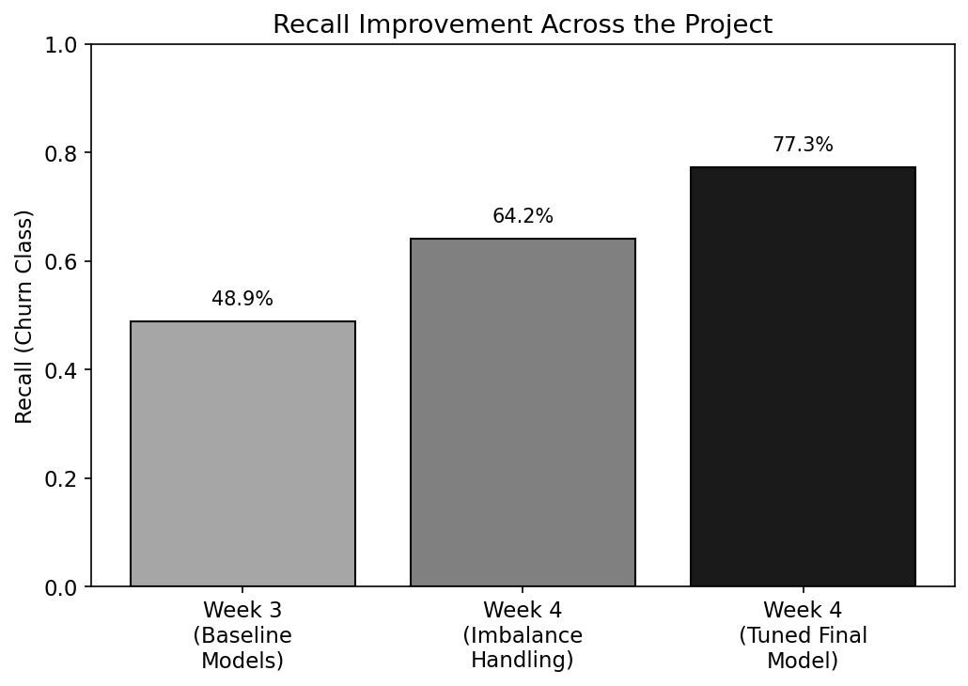
Figure 1: Recall improvement across the project, from Week 3 baselines to the final tuned model

6. Final Model Evaluation
The tuned Random Forest was selected as the final model, achieving the highest F1-score of any configuration tested (0.629), recall of 77.3%, and ROC-AUC of 0.842.
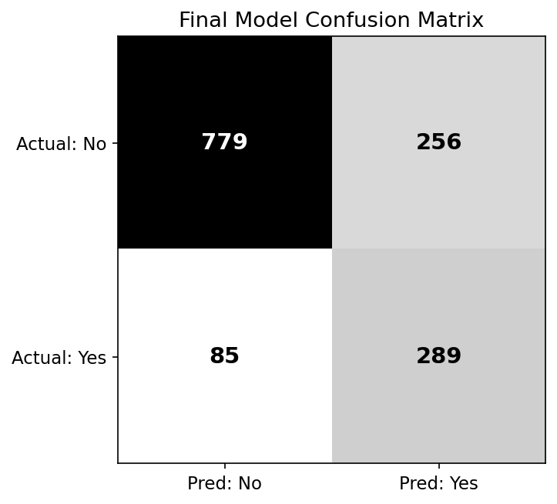
Figure 2: Final model confusion matrix
- Accuracy (75.8%): the model correctly classifies about 76 of every 100 customers.
- Precision (53.0%): when the model flags a customer as a churn risk, it is correct about half the time; the cost of a false alarm is a low-value retention offer.
- Recall (77.3%): the model correctly identifies about 3 in 4 customers who actually churn, the most business-critical metric, since a missed churner represents fully lost revenue.
- ROC-AUC (0.842): strong discriminative ability across all decision thresholds.

7. Feature Importance
The final model's feature importance closely matched the six insights identified independently through exploratory analysis in Week 2, providing strong evidence that the manual analysis was sound.
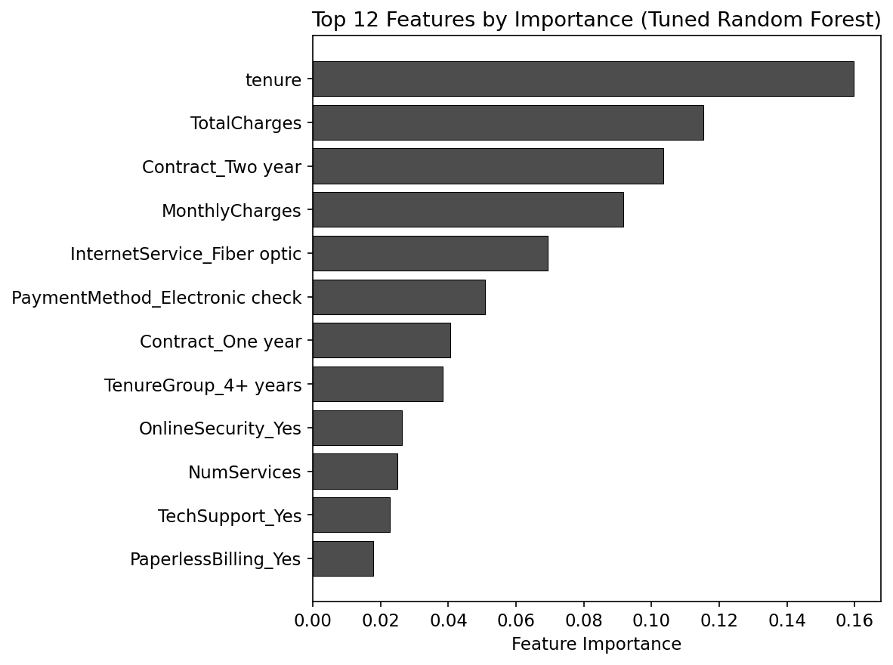
Figure 3: Top 12 features by importance, tuned Random Forest
tenure (16.0%), TotalCharges (11.5%), Contract_Two year (10.3%), MonthlyCharges (9.2%), and InternetService_Fiber optic (6.9%) were the five most important features, directly corresponding to Insights 1 through 4 from the EDA phase.

8. Model Error Analysis
False negatives (85 customers, 22.7% of actual churners) were disproportionately borderline: 75% had a predicted churn probability below 0.44, with a maximum of 0.4999, just under the 0.50 decision threshold. These churners did not display the short-tenure warning signs the model relies on most heavily, making them inherently harder to detect.
False positives (256 customers) showed high average predicted probability (0.681) and skewed toward newer, higher-paying customers, matching the general at-risk profile without actually churning. This is a lower-cost error, a retention offer sent to a loyal customer is a minor, recoverable expense compared to losing a customer outright.
Business implication: since many false negatives sit just below the decision threshold, lowering the classification cutoff (e.g., from 0.50 to 0.40) is a tunable lever that could catch more at-risk customers at the cost of accepting more low-cost false alarms.

9. Business Recommendations
1. Incentivize migration off month-to-month contracts. Offer a discount or free add-on for switching to a one- or two-year contract, particularly for customers already flagged as high-risk by the model.
2. Create a dedicated onboarding and retention program for a customer's first 12 months, with structured check-ins at 3, 6, and 9 months, since tenure is the single strongest churn predictor.
3. Investigate fiber optic service quality and pricing directly, via a targeted customer satisfaction survey, given fiber customers churn at nearly double the DSL rate despite being the premium product.
4. Incentivize a shift from electronic check to automatic payment methods (e.g., a one-time bill credit), since electronic check users churn at roughly 3x the rate of automatic payment users.
5. Deploy the model with a lowered decision threshold (e.g., 0.40) for retention outreach, to catch more borderline at-risk customers, since the low cost of a false alarm justifies accepting more of them.
6. Prioritize senior citizens in retention campaigns, via a dedicated support line or simplified plan options, since this segment churns at nearly double the rate of non-seniors despite being a smaller share of the customer base.

10. Limitations and Future Improvements
- The dataset represents a single snapshot in time; a longitudinal dataset tracking customers over multiple periods could capture behavior changes leading up to churn, rather than a single point-in-time profile.
- Precision remains moderate (53.0%); further threshold tuning or cost-sensitive learning could better balance false positives against the specific retention budget available to the business.
- Additional models (e.g., XGBoost, gradient boosting) were not tested in this iteration and could be explored for further performance gains.
- The model does not incorporate external factors such as competitor pricing changes or regional network quality data, which likely influence churn but were not present in this dataset.

11. Conclusion
This project successfully developed an end-to-end machine learning workflow for customer churn prediction, from raw data cleaning through a tuned, validated final model. The final Random Forest model catches 77.3% of actual churners, a substantial improvement over the 49-52% recall of initial baseline models, while maintaining strong overall discriminative ability (ROC-AUC 0.842). Combined with the six validated business recommendations, this project provides a practical foundation a telecom company could use to reduce revenue loss from customer churn.

